Ex.No.5 Experiments on Packet capture tool: Wireshark
AIM:
To understand the features of wireshark as a packet capture tool and understand encapsulation
of information at various layers of a Protocol stack.
WIRESHARK
Wireshark is a free, open-source network packet analyzer used for network troubleshooting,
analysis, and security auditing. It lets you capture and interactively browse live data traffic
passing through a network interface:
Workdone by Wireshark:
1) Capture network traffic
2) Decode packet protocols using dissectors
3) Define filters – capture and display
4) Watch smart statistics
5) Analyze problems
6) Interactively browse that traffic
Wireshark used for:
7) Network administrators: troubleshoot network problems
8) Network security engineers: examine security problems
9) Developers: debug protocol implementations
10) People: learn network protocol internals
Getting Wireshark
Wireshark can be downloaded for Windows or macOS from its official website. For
Linux or another UNIX-like system, Wireshark will be found in its package
repositories. For Ubuntu, Wireshark will be found in the Ubuntu Software Center.
Download Wireshark from the following link
https://www.wireshark.org/download.html
Procedure to Capture Packets Using Wireshark
Step 1: Download and install Wireshark on your computer.
Step 2: Open the Wireshark application.
Step 3: From the home screen, select the network interface (e.g., Wi-Fi or Ethernet) through
which your computer is connected to the network.
Step 4: Click the Start Capturing Packets button (blue shark fin icon) or double-click the
selected interface.
Step 5: Generate network traffic by opening a website, sending a ping, or browsing the
Internet.

Step 6: Observe the captured packets appearing in real time in the Packet List pane.
Step 7: To view only specific packets, enter a display filter (e.g., http, tcp, udp, icmp, dns)
in the filter bar and press Enter.
Step 8: Click on any packet to view its detailed information in the Packet Details pane.
Step 9: Expand the protocol layers (Ethernet, IP, TCP/UDP, etc.) to examine packet contents.
Step 10: Click the Stop button (red square) to stop packet capture.
Step 11: To save the captured packets, go to File → Save As, choose a location, and save the
file in .pcapng (or .pcap) format.
1. Packet List Pane (Top Pane)
1) Displays a summary of all captured packets.
2) Each row represents one captured packet.
3) Shows details such as Packet Number, Time, Source, Destination, Protocol,
Length, and Info.
2. Packet Details Pane (Middle Pane)
1) Displays detailed information about the selected packet.
2) Information is organized into protocol layers such as Frame, Ethernet, IP,
TCP/UDP, etc.
3) Each protocol layer can be expanded to view more details.
3. Packet Bytes Pane (Bottom Pane)
1) Displays the raw data of the selected packet.
2) Data is shown in hexadecimal format on the left.
3) The corresponding ASCII representation is shown on the right.
Note: These three panes work together to help users analyze captured network packets
efficiently in Wireshark.
Color Coding:
In Wireshark, packet colors help you quickly identify different types of network traffic.
Based on your screenshot, the colors indicate the following:
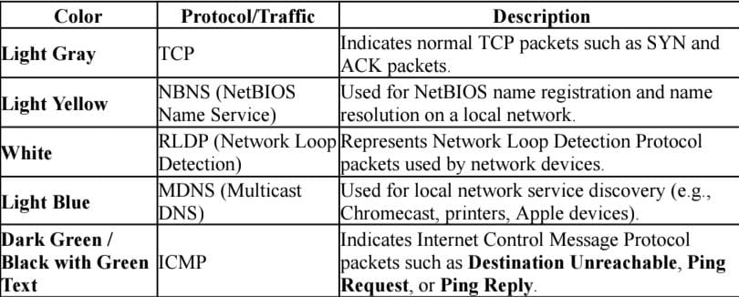
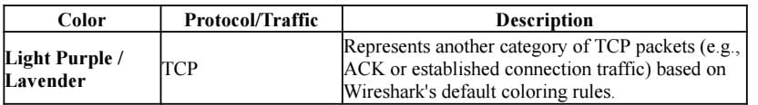
To view exactly what the color codes mean, click View &gt; Coloring Rules. You can
also customize and modify the coloring rules from here, if you like.
Sample Captures:
1) If there is no interesting network traffic on your own network, you can use sample
capture files.
2) Download a sample capture file and open it by selecting File → Open in Wireshark.
3) Browse to the downloaded file and click Open to analyze the captured packets.
4) You can also save your own captured packets for future analysis by selecting File →
Save.
5) Wireshark saves capture files in .pcap or .pcapng format.
Simple Procedure:
1. Download a sample capture file.
2. Open Wireshark.
3. Click File → Open.
4. Select the sample capture file.
5. Analyze the captured packets.
6. To save your own capture, click File → Save.
You can also save your own captures in Wireshark and open them later. Click File &gt; Save to save
your captured packets
Filtering Packets:
1) Close unnecessary applications before capturing packets.

2) This reduces unwanted network traffic.
3) Capture only the traffic related to the program you want to analyze.
4) Without filters, thousands of packets may be captured.
5) Filters help narrow down the packet list.
6) This makes packet analysis faster and easier.
7) Wireshark provides Capture Filters and Display Filters to simplify traffic analysis.
Sample filter applied for TCP:
Filtered Packet List
No. Time Source Destination Protocol Length Info
1 0.001 192.168.1.10 142.250.183.78 TCP 74 50234 → 443 [SYN]
2 0.005 142.250.183.78 192.168.1.10 TCP 74 443 → 50234 [SYN, ACK]
3 0.006 192.168.1.10 142.250.183.78 TCP 66 50234 → 443 [ACK]
4 0.020 192.168.1.10 142.250.183.78 TCP 1514 HTTP GET Request
5 0.055 142.250.183.78 192.168.1.10 TCP 1514 HTTP 200 OK

Display Filters in Wireshark:
1) Click Analyze → Display Filters to open the list of available display filters.
2) Choose a predefined filter from the default list.
3) You can create your own custom filters.
4) Save custom filters for future use.
5) Display filters make it easier to find specific packets.
6) For advanced filter syntax, refer to the official Wireshark Display Filter
documentation.
Example: Create and Save a Custom Filter
Suppose you frequently analyze DNS packets.
1. Click Analyze → Display Filters.
2. Click the + (Add) button.
3. Enter:
o Filter Name: DNS Packets
o Filter Expression: dns
4. Click OK.
Follow TCP Stream in Wireshark
1. Right-click on a TCP packet.
2. Select Follow → TCP Stream.
3. Wireshark displays the complete conversation between the client and the server.
4. This helps you understand the data exchanged during the communication.
5. You can also choose Follow → UDP Stream or other available protocol streams, if
supported.
6. This feature is useful for analyzing web requests, application data, and
troubleshooting network communication.
Sample Captures:
If there is no interesting network traffic on your own network, you can use sample
capture files.
Download a sample capture file and open it by selecting File → Open in Wireshark.
Browse to the downloaded file and click Open to analyze the captured packets.
You can also save your own captured packets for future analysis by selecting File →
Save.
Wireshark saves capture files in .pcap or .pcapng format.
Simple Procedure:
1. Download a sample capture file.
2. Open Wireshark.
3. Click File → Open.
4. Select the sample capture file.
5. Analyze the captured packets.
6. To save your own capture, click File → Save.
You can also save your own captures in Wireshark and open them later. Click File &gt; Save to save
your captured packets
Filtering Packets:
Close unnecessary applications before capturing packets.

This reduces unwanted network traffic.
Capture only the traffic related to the program you want to analyze.
Without filters, thousands of packets may be captured.
Filters help narrow down the packet list.
This makes packet analysis faster and easier.
Wireshark provides Capture Filters and Display Filters to simplify traffic analysis.
Sample filter applied for TCP:
Filtered Packet List
No. Time Source Destination Protocol Length Info
1 0.001 192.168.1.10 142.250.183.78 TCP 74 50234 → 443 [SYN]
2 0.005 142.250.183.78 192.168.1.10 TCP 74 443 → 50234 [SYN, ACK]
3 0.006 192.168.1.10 142.250.183.78 TCP 66 50234 → 443 [ACK]
4 0.020 192.168.1.10 142.250.183.78 TCP 1514 HTTP GET Request
5 0.055 142.250.183.78 192.168.1.10 TCP 1514 HTTP 200 OK

Click Analyze → Display Filters to open the list of available display filters.
Choose a predefined filter from the default list.
You can create your own custom filters.
Save custom filters for future use.
Display filters make it easier to find specific packets.
For advanced filter syntax, refer to the official Wireshark Display Filter
documentation.
Example: Create and Save a Custom Filter
Suppose you frequently analyze DNS packets.
1. Click Analyze → Display Filters.
2. Click the + (Add) button.
3. Enter:
o Filter Name: DNS Packets
o Filter Expression: dns
4. Click OK.
Follow TCP Stream in Wireshark
1. Right-click on a TCP packet.
2. Select Follow → TCP Stream.
3. Wireshark displays the complete conversation between the client and the server.
4. This helps you understand the data exchanged during the communication.
5. You can also choose Follow → UDP Stream or other available protocol streams, if
supported.
6. This feature is useful for analyzing web requests, application data, and
troubleshooting network communication.
Flow Graph in Wireshark
Definition:
A Flow Graph visually represents the sequence of communication between different devices
(hosts) in a network. It makes it easier to understand how packets are exchanged.
How to Open Flow Graph
1. Open a packet capture (.pcap) file.
2. Click Statistics → Flow Graph.
3. A Flow Graph window appears showing the communication between hosts.
What the Graph Shows
Vertical lines represent different network devices (hosts).

Horizontal arrows represent packets sent between hosts.
Time is shown from top to bottom.
Each arrow is labeled with the protocol and packet information.
Example:
Yes. Below is a sample Flow Graph output similar to what you would see in Wireshark
after selecting Statistics → Flow Graph.
Wireshark Capture Options:

Go to capture → option
Select stop capture automatically after 100 packets.
Then click Start capture.

Step 1: Select the Active Interface
In your screenshot, choose the interface that is currently connected to the network.
If you are using Wi-Fi, click Wi-Fi.
If you are using a LAN cable, click Ethernet.
Tip: The active interface usually shows a moving graph or increasing traffic. In your
screenshot, Wi-Fi is likely the correct choice if you are connected wirelessly.
Step 2: Go to the Options Tab
Click the Options tab at the top.
You will see settings similar to this:
☑ Stop capture automatically after

Step 3: Set the Packet Limit
Check the option:

☑ Stop capture automatically after
Select:
100 Packets
Creating a Filter to display only DHCP packets and inspect the packets.

Procedure
1. Open Wireshark.
2. Select the Ethernet (Local Area Connection) or Wi-Fi interface.
3. Click Capture → Options.
4. Select Stop capture automatically after 100 packets.
5. Click Start to begin packet capture.
6. Generate DHCP traffic by disconnecting and reconnecting the network, or by running:
7. ipconfig /release
ipconfig /renew
8. After the capture stops, type the following in the Display Filter bar:
dhcp
(If dhcp does not work, use bootp.)
9. Press Enter or click Apply to display only DHCP packets.
10. Click any DHCP packet to inspect its details.
11. Click File → Save As, enter a filename, and save the captured packets as a .pcapng file.
Create a Filter to display only IP/ICMP packets and inspect the
packets. Procedure
Step 1: Check if ping is working
1. Press Windows + R.
2. Type cmd and press Enter.
3. Type:
ping 8.8.8.8
4. Press Enter.
What do you see?
• If you see:
Reply from 8.8.8.8...
then the ping is working.
• If you see:
Request timed out

or
Ping request could not find host...
tell me exactly what message appears.
Step 2: Check whether Wireshark is capturing
When you click Start Capture, do you see the packet count increasing continuously?
• Yes → Wireshark is capturing.
• No → The wrong network interface is selected.
Step 3: Verify the filter
After capturing packets, clear any existing filter and type:
icmp
If the filter bar turns green, the filter is valid.
If it stays green but shows 0 packets, then no ICMP packets were captured.
Step 4: Easier alternative
Instead of using ping, try this:
1. Start Wireshark.
2. Open Google Chrome.
3. Visit www.google.com.
4. Stop the capture.
5. In the Display Filter, type:
dns
or
tcp
6. Press Enter.
These filters almost always show packets because web browsing generates DNS and TCP
traffic.
Sample Output (ICMP Filter)
Display Filter:
icmp
Packet List
No. Time Source Destination Protocol Length Info
15 2.345 192.168.1.10 8.8.8.8 ICMP 74 Echo (ping) request

16 2.356 8.8.8.8 192.168.1.10 ICMP 74 Echo (ping) reply
17 3.347 192.168.1.10 8.8.8.8 ICMP 74 Echo (ping) request
18 3.359 8.8.8.8 192.168.1.10 ICMP 74 Echo (ping) reply
19 4.351 192.168.1.10 8.8.8.8 ICMP 74 Echo (ping) request
20 4.362 8.8.8.8 192.168.1.10 ICMP 74 Echo (ping) repl

OUTPUT:
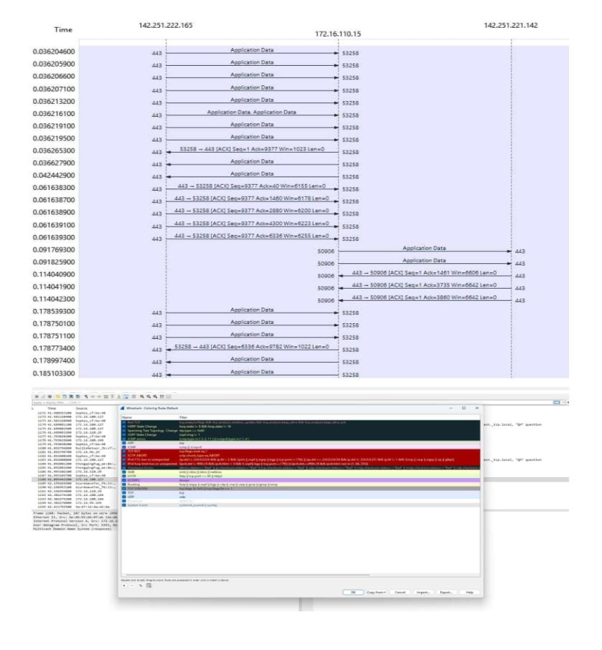
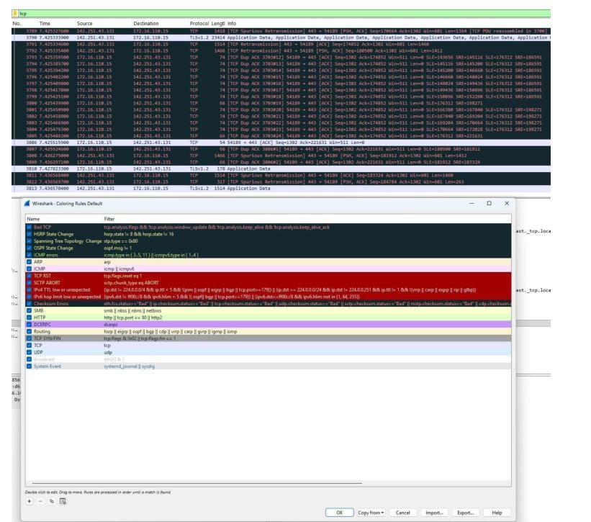
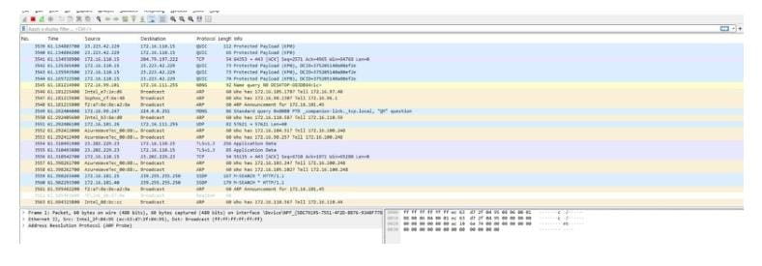
RESULT:
Thus experiments on packet capture tool: Wireshark is studied.

